FAQ

## How to determine which port to use for the connection in the Window application?

To determine which port your Bluetooth is using to connect to the Brick you need to look that up.   
In Windows that is via: *Devices and Printers* -> *Right click on [Brick name*] -> *Properties* -> *Hardware-tab* -> The port is specified between parenthesis in the name (see image below).

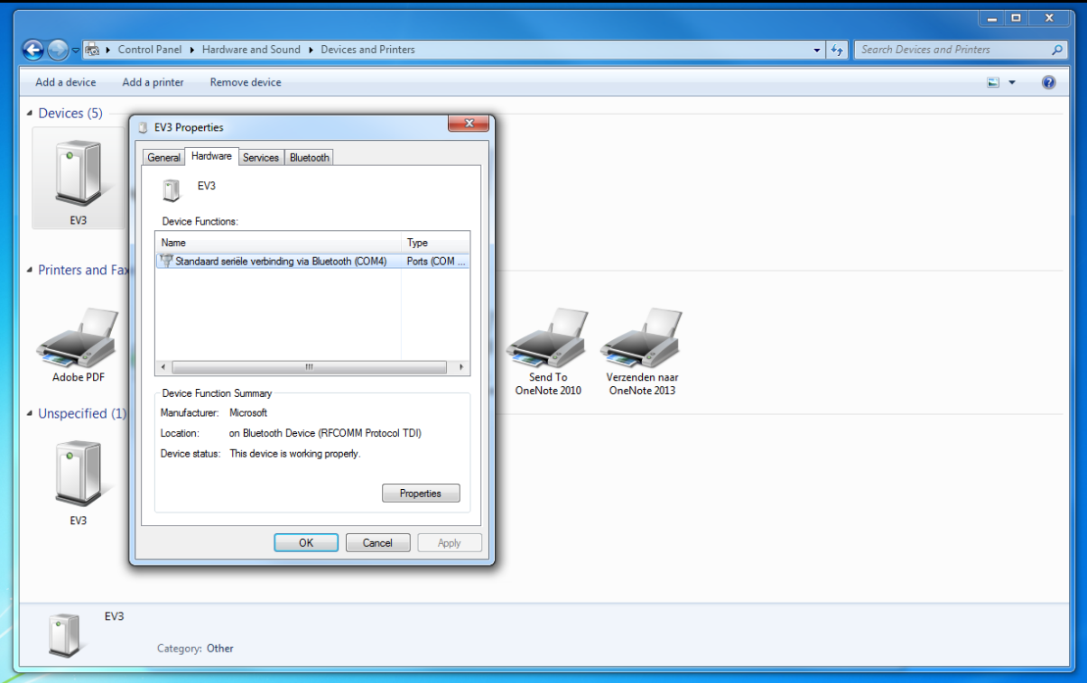

Figure 1: Example in Windows

## Where can I find the Lego Mindstorms IDE?

<http://lmgtfy.com/?q=Lego+Mindstorms+IDE>

## Why is the Brick not picking up the message I’ve send?

Make sure that in the logic block the *Message Title* matches with what is supplied as the first parameter in the method call *SendMessage("MESSAGE_TITLE",”MESSAGE”)*.

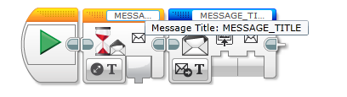

Figure 2: Example of two logic blocks

## How does the DLL process the message send from the Brick?

The DLL has a queue where all the messages received from the Brick are stored. Every time the method *messenger.ReadMessage()* is called the oldest method is returned. If there are no message *null* will be returned.

# The Brick is frozen/crashed

You can do a reset by pressing the middle & back button. See the image below which buttons these are.

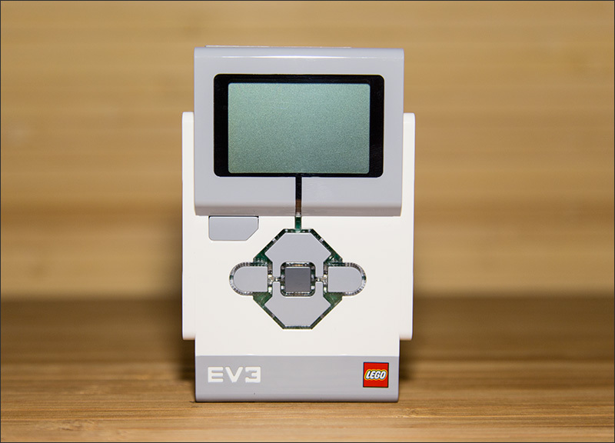

# I can’t find the Ultra Sonic sensor in the Lego Mindstorm IDE

The home edition of the Lego Mindstorm IDE doesn’t include the Ultra Sonic sensor. To be able to make use this you need to install this manually.   
If you go to the download page were you found the IDE you can also find a paragraph called “EV3 Software Block Download”. Here you can download the senor block.